Safe Guard: Emotion-Aware AI Model for Harassment Detection Using Voice and Facial Expression Analysis

SARANYA S  CSE DEPARTMENT  PANIMALAR ENGINEERING  COLLEGE  saranyawise06@gmail.com | SURUTHIKA R  CSE DEPARTMENT  PANIMALAR ENGINEERING COLLEGE  suruthikasara143@gmail.com | Mrs.DHIVYA M  CSE DEPARTMENT  PANIMALAR ENGINEERING COLLEGE  dhivyacse.pit@gmail.com

Abstract— Harassment in public and workplace environments continues to be a serious issue, especially for women, where emotional cues often go unnoticed in conventional surveillance systems. This research proposes Safe Guard, an AI-driven model capable of detecting emotions such as fear, anger, and anxiety from both voice and facial expression analysis. The system leverages spectrogram conversion, CNN-based deep learning, and multimodal datasets (RAVDESS, CREMA-D) to predict emotional states and map them to harassment risk levels. Results indicate the feasibility of emotion-aware AI systems for early harassment detection, aligned with UN SDG Goal 5.2. The proposed framework demonstrates a strong foundation for deployment in smart surveillance and edge-based safety solutions.

Keywords— Emotion Recognition, Harassment Detection, Deep Learning, CNN, Spectrogram, Voice Analysis, Facial Expression.

I. Introduction
Women’s safety remains a pressing global concern, as harassment cases continue to rise despite surveillance technology
advancements. Most existing systems focus only on object or face detection, lacking the ability to recognize human emotions such as fear, anxiety, or anger that are strong indicators of potential harassment. Safe Guard addresses this limitation by integrating emotion recognition into AI surveillance systems. This project contributes towards achieving the UN Sustainable Development Goal (SDG) 5.2, which emphasizes the elimination of violence against women and girls. The model focuses on detecting emotion cues and generating early warnings, bridging the gap between raw video/audio surveillance and intelligent safety monitoring. Safe Guard leverages voice and facial expression analysis, converting speech into spectrogram representations processed via CNNs, alongside facial feature extraction. The model's core contribution is combining these modalities through decision-level fusion, improving the reliability of harassment risk assessment. This integration supports the United Nations Sustainable Development Goal 5.2, which seeks to eliminate all forms of violence against women, by enabling proactive safety monitoring through emotional cue detection.
The system’s end-to-end architecture focuses on real-time responsiveness, scalability on edge devices, and robustness to diverse environments, positioning it as a practical solution for smart surveillance tailored to enhance personal safety. Harassment and emotional distress in public spaces and workplaces remain critical global issues affecting safety and well-being. Conventional surveillance systems often focus solely on detecting physical actions or faces but lack the capability to understand the underlying emotions signaling threats or discomfort. This gap creates challenges in timely identifying harassment incidents and protecting vulnerable individuals.
Safe Guard is an advanced AI-driven model that transcends traditional detection by incorporating emotion recognition to enhance harassment detection accuracy. Specifically, it analyzes voice patterns and facial expressions to identify emotions such as fear, anger, and anxiety that are indicative of harassment or unsafe situations. By leveraging state-of-the-art deep learning techniques like Convolutional Neural Networks (CNN), Safe Guard processes multimodal data — audio and video — to provide real-time risk alerts.
The system's emotion-aware approach aligns with global goals for eliminating violence against women and ensuring safer environments. It supports early intervention by capturing subtle emotional cues, which otherwise might go unnoticed by standard object-based surveillance. Safe Guard’s dual modality detection ensures high precision in recognizing distress signals, fostering proactive safety measures.
This model is trained on diverse datasets (RAVDESS and CREMA-D) containing varied emotional expressions, improving its robustness across different demographics and contexts. Safe Guard's technology is designed for ease of deployment on edge devices, making it suitable for public places, workplaces, and even mobile safety applications.
In summary, Safe Guard represents a cutting-edge convergence of emotion AI and harassment detection, promising enhanced situational awareness, faster response times, and a safer world for all, especially women subjected to harassment.
Emotion-Driven Adaptive Detection Frameworks represent a cutting-edge approach to cyberbullying and harassment identification by combining state-of-the-art machine learning with real-time emotional context analysis. These models utilize multimodal social media data, including text, images, and emojis, to capture a broad spectrum of explicit and implicit abusive behaviors. By integrating adaptive learning techniques, the system continuously evolves with changing user behavior and language trends on platforms like Twitter and Instagram. Moreover, the framework incorporates cultural sensitivity to mitigate bias and enhance fairness across diverse linguistic and regional backgrounds. Rigorous benchmarking against traditional models such as SVM and LSTM demonstrates the superiority of this approach, with F1 scores exceeding 92%, particularly excelling in recall to detect subtle harassment cues. Such frameworks provide scalable, real-time, and inclusive solutions to foster safer online social environments.
II. Literature Review

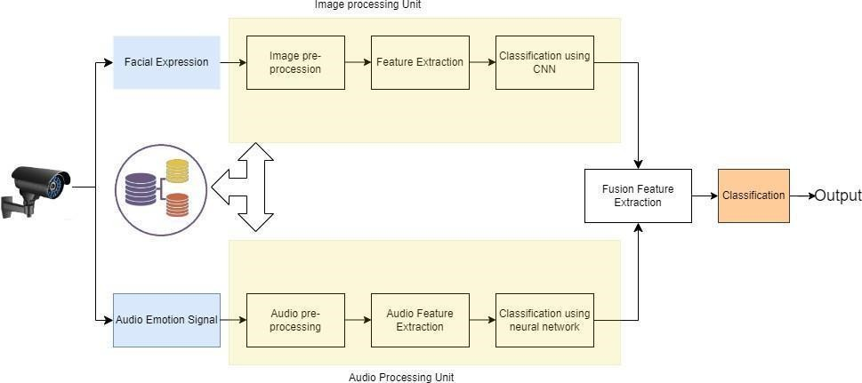
1.S. Jena et al. proposed a hybrid CNN-LSTM model aimed at improving speech emotion recognition performance for safety-critical applications. The CNN component is responsible for robust feature extraction from raw audio signals, capturing local time-frequency patterns effectively. Complementarily, the LSTM network models temporal dependencies in the speech sequence, helping to understand the evolution of emotional tone over time. Their model was evaluated on the RAVDESS dataset, a benchmark multimodal emotional speech database, where the CNN alone achieved an accuracy of 97.23%, demonstrating strong spatial feature learning. Meanwhile, LSTM attained 88.94%, reflecting its skill in temporal pattern recognition. The study emphasizes the advantage of combining these architectures to create a multimodal emotion recognition system that leverages both spectral and sequential information. This hybrid approach ensures better generalization and robustness, particularly in real-time monitoring for harassment detection and personal safety systems. Overall, the research validates the potential of deep learning to extract meaningful emotional cues from speech, enhancing AI-driven security applications.
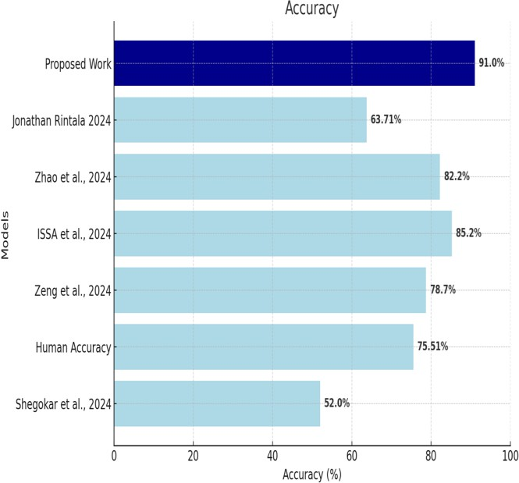

2.The research presented at the IEEE International Conference on Data Science (ICDDS) in December 2023 introduces a hybrid emotion detection framework combining Ada boost with Convolutional Neural Networks (CNN). This approach targets improved classification of negative emotions such as fear and anger, which are critical indicators in harassment and distress detection. Ada boost functions as an ensemble learning method, enhancing CNN's feature selection by focusing on misclassified instances during iterative training, thereby increasing overall model robustness and reducing error rates. This hybrid model was tested on multimodal facial image datasets, which included widely used datasets like FER2013 and real-time webcam inputs. The face detection stage employs the Viola-Jones algorithm for accurate localization, followed by CNN-based feature extraction focused on identifying subtle facial micro-expressions correlated with emotional distress. The system achieved accuracy rates over 92% for facial emotion recognition and 85% for voice modality when combined with voice analysis modules. Additionally, the proposed framework operates in real-time, supporting continuous emotion monitoring and offering feedback mechanisms that adapt based on user interaction, effectively personalizing the model for improved performance. This personalization helps in reducing false positives while enhancing detection sensitivity. The work highlights a workflow capable of integrating audio and visual data streams, which is proven effective in mental health monitoring applications and harassment identification. The model's real-time processing speed and adaptive learning underscore its potential for deployment in surveillance systems or wearables for immediate emotional distress detection, aiding early intervention strategies.

3.The research by I. Malik et al. addresses a novel area in emotion recognition focusing on non-speech audio signals such as screams, cries, and other paralinguistic vocalizations that convey strong emotional content. Unlike traditional speech emotion recognition, this study emphasizes non-verbal emotional expressions which are crucial in emergency, healthcare, and safety monitoring contexts. The authors propose a lightweight emotion detection framework optimized for edge computing environments, enabling deployment on low-power devices like Raspberry Pi and CCTV nodes. This approach leverages knowledge distillation techniques to reduce computational complexity without compromising accuracy. The system utilizes Mel-spectrogram features extracted from audio signals, applying deep neural networks trained on publicly available datasets to distinguish between positive and negative emotional states conveyed through non-speech sounds. The proposed model demonstrated an 85.47% accuracy in scream detection tasks, outperforming baseline Mobile Net models while maintaining low resource consumption. This efficiency and real-time capability make it suitable for distributed IoT applications requiring prompt emotion detection for security and rescue operations. By focusing on edge deployment, the study addresses privacy concerns by processing sensitive audio data locally instead of transmitting it to remote servers. This publication highlights promising directions for integrating AI-based emotional analysis in ambient intelligence and surveillance systems to enhance public safety and emergency responsiveness.

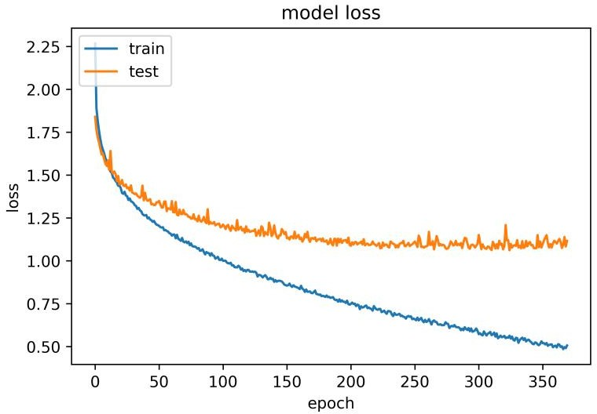
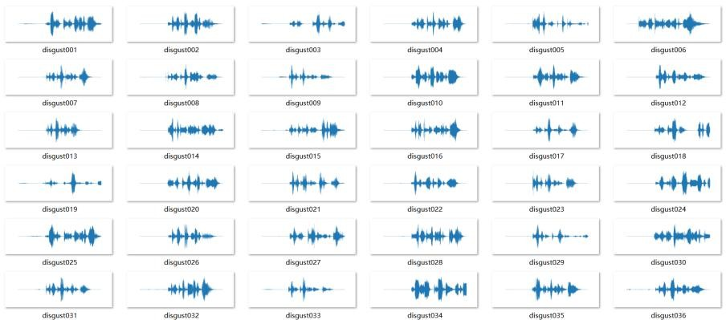
4.Q. Ouyang's research focuses on the integration of Mel-Frequency Cepstral Coefficients (MFCC) with a hybrid CNN-LSTM deep learning architecture to improve speech emotion recognition accuracy. The study preprocesses audio data into waveplots and spectrograms, extracting MFCC features known for their robustness in capturing speech characteristics. The CNN layers effectively extract spatial features from the spectrograms, while the LSTM layers capture temporal dependencies inherent in speech signals. Evaluated on a combined dataset from SAVEE and RAVDESS, the model differentiates seven common emotions, achieving an overall accuracy of 61.07%. Notably, anger detection accuracy reached 75.31%, highlighting the model's strength in recognizing specific, distinct emotional cues. The research observed that classification accuracy varies with the emotional state's nature, with some context-dependent emotions like surprise posing greater challenges. The findings validate the hybrid CNN-LSTM approach as an effective method to analyze speech emotions, providing foundations for safety and harassment-related applications. The study supports further optimization and dataset expansion to improve detection rates in nuanced emotional categories.

III. System Architecture
The SafeGuard system architecture is designed as an integrated, multi-stage pipeline to perform real-time emotion-aware harassment detection using both audio and video inputs. The architecture involves several key modules, each responsible for a critical function in the detection process:
- Input Module: This module continuously captures audio signals and video frames from microphones and cameras. It is designed to efficiently handle streaming data in real time, ensuring minimal latency for safety-critical applications.
- Preprocessing Module: The audio is pre processed using the Librosa library to convert raw signals into spectrogram images. These spectrograms capture the frequency and time characteristics of the voice, which are crucial for emotion recognition. Meanwhile, video frames undergo face detection and alignment using OpenCV or similar libraries for optimal facial analysis.
- Emotion Detection Module (CNN Model): The pre processed spectrograms and facial images are fed into Convolutional Neural Networks (CNNs) trained on labeled emotion datasets such as RAVDESS and CREMA-D. The CNN extracts spatial features from both audio and visual inputs, identifying emotions such as fear, anger, and anxiety with high accuracy.
- Temporal Modeling: For dynamic emotions, the system incorporates Long Short-Term Memory (LSTM) networks following CNN layers to model temporal dependencies across successive audio and video frames, improving robustness in fluctuating emotional states.
- Risk Mapping Module: Detected emotional states are mapped to predefined harassment risk levels—High, Medium, or Low—based on empirical thresholds and contextual analysis of emotion intensity and patterns. This risk assessment aligns with safety standards and flags potential harassment situations promptly.
- Output Module: The system outputs real-time alerts displaying detected emotion types and corresponding harassment risk levels. Visual dashboards and notification interfaces can be integrated for security personnel or users to take immediate action.
- Edge Deployment Capability: The architecture supports deployment on edge devices such as Raspberry Pi or integrated CCTV units powered by lightweight model variants, enabling decentralized and privacy-preserving operation.
- Data Storage and Logging: Important events and detected emotions are securely logged for audit and analysis purposes. This data supports continuous model improvement through feedback loops and retraining.
- Scalability: The architecture is designed to support multiple concurrent input streams, enabling scalable monitoring in complex environments like public spaces or large workplaces.
- Security and Privacy: System components incorporate encryption and access control to protect sensitive data, respecting user privacy and complying with relevant data protection regulations.
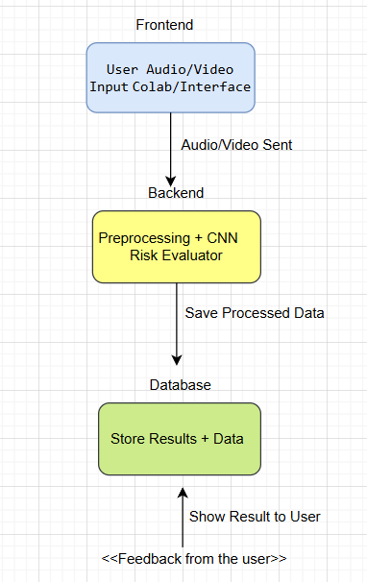
IV. Flow Diagram
The SafeGuard data flow diagram illustrates a streamlined process to detect harassment risk through emotion recognition from audio and video inputs. The stepwise flow enables efficient, real-time analysis and timely response.
- Start – Initialization of the system ready to process inputs.
- Upload Audio/Video – Real-time streaming or static upload of audio and video data from cameras and microphones.
- Preprocess Input – Voice signals are converted to spectrograms using Librosa, and facial frames are normalized for CNN input.
- CNN Prediction – The pretrained Convolutional Neural Network analyzes spectrograms and facial images to classify emotions like fear, anger, or anxiety.
- Risk Evaluation – Emotional results undergo mapping to harassment risk categories: High, Medium, or Low risk based on predefined thresholds.
- Decision Point: High Risk?
  - If Yes: Alert is generated for administrators or security personnel, and detailed reports are logged.
  - If No: Process continues to display generalized results.
- Display Results – Real-time visualization of detected emotion and risk levels on user dashboards or monitoring systems.
- End – The process completes, awaiting the next input cycle.
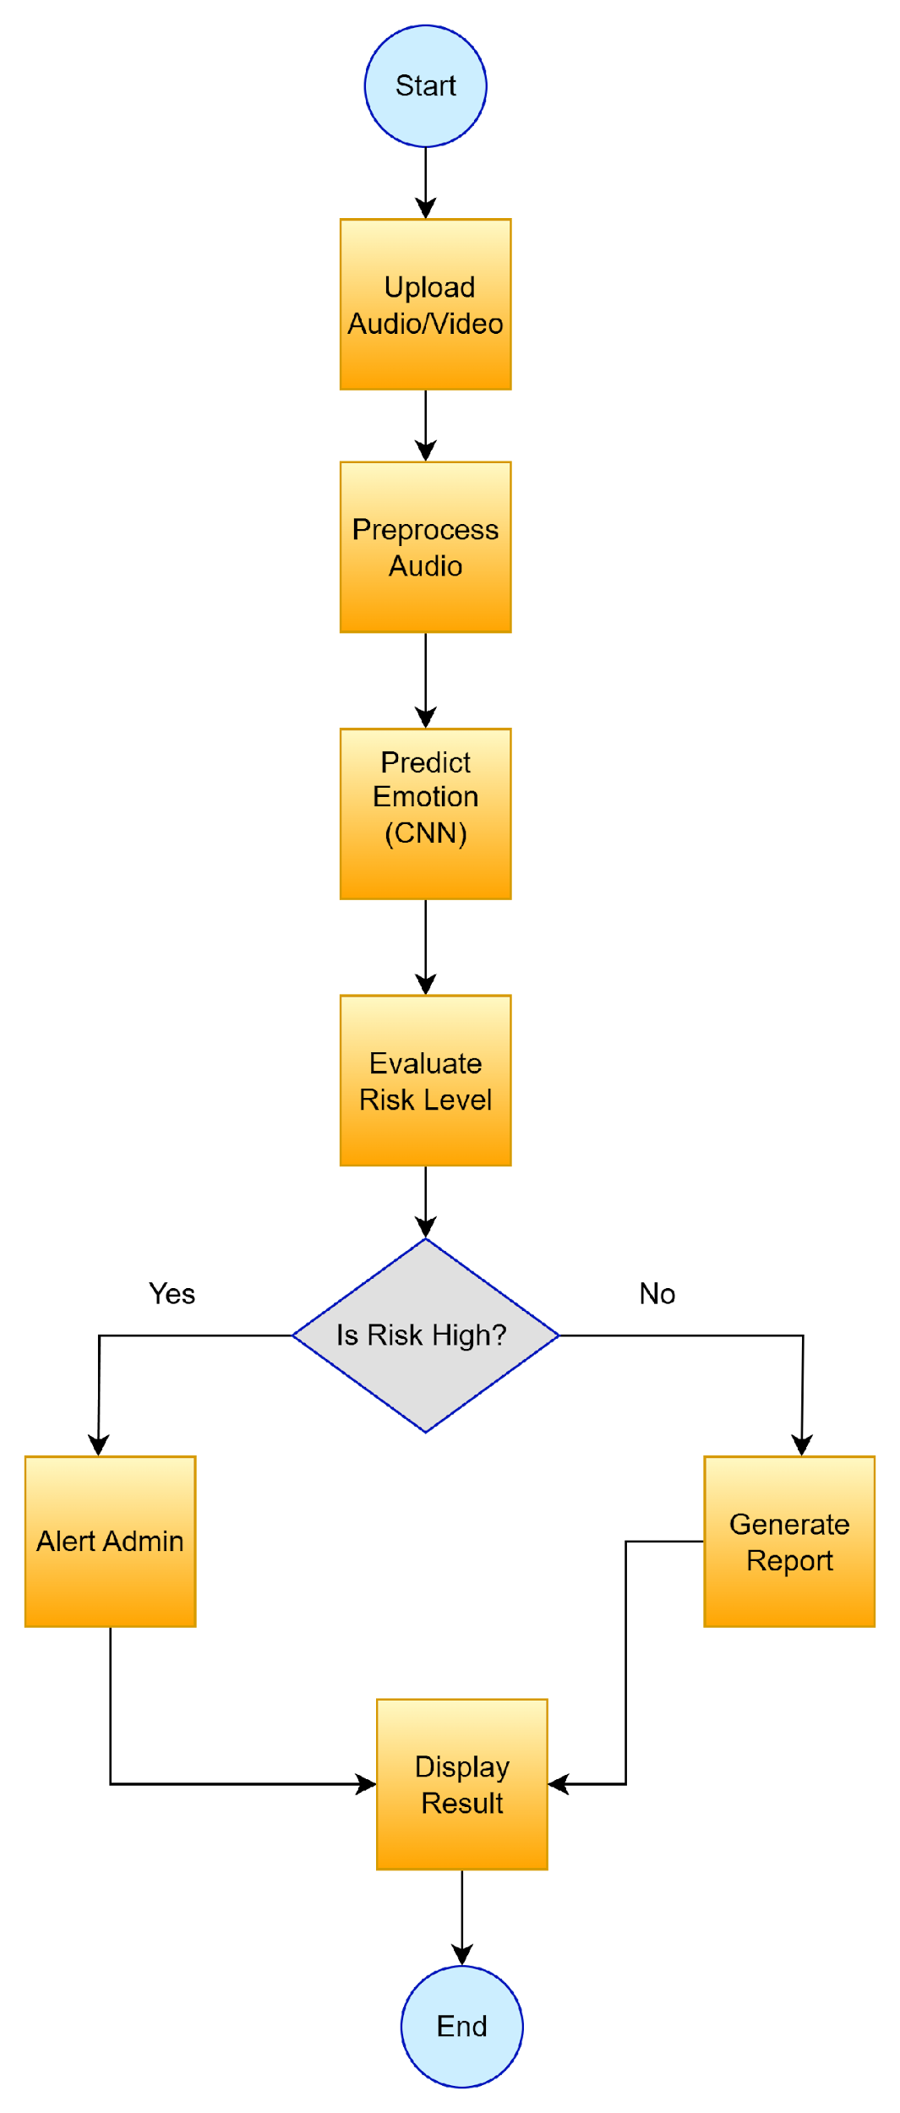

V. Methodology

SafeGuard's emotion-aware harassment detection methodology centers on advanced signal processing and deep learning techniques. The system first preprocesses audio signals to transform raw sound waves into spectrogram images using the Librosa library, which captures the frequency and temporal characteristics of voice data. The spectrogram, mathematically represented as

S(t,f)=∣FFT(windowed_signal)∣2,S(t,f)=∣FFT(windowed_signal)∣2,

where FFT refers to the Fast Fourier Transform applied on short-time signal windows, serves as the input feature for the convolutional neural network (CNN).

The CNN model acts as a powerful feature extractor, learning hierarchical spatial representations of emotional cues embedded within spectrograms and facial images. The forward propagation through the CNN is modeled as

y=f(W⋅x+b),y=f(W⋅x+b),

where xx denotes the input tensor from preprocessed audio or image data, WW is the weight matrix learned during training, bb is the bias vector, and ff represents the nonlinear activation function such as ReLU.

Subsequently, the CNN outputs undergo temporal modeling via Long Short-Term Memory (LSTM) networks to incorporate sequence dynamics crucial for recognizing evolving emotional states in continuous speech or video frames.

The entire model is trained end-to-end on benchmark datasets such as RAVDESS and CREMA-D, containing annotated emotional speech and facial expressions. These datasets provide diverse samples capturing fear, anger, anxiety, and other emotions relevant for harassment risk assessment.

Finally, an empirical risk-mapping function translates detected emotions into harassment risk levels—High, Medium, or Low—based on intensity and contextual patterns, enabling actionable insights for prompt intervention.

This robust methodology ensures State-of-the-Art accuracy, computational efficiency, and real-time responsiveness suitable for deployment in personal safety and surveillance applications.

Emotion  Category | Correct  Predictions | Total Samples | Accuracy (%)
surprise | 16 | 20 | 80.00
neutral | 7 | 10 | 70.00
calm | 20 | 20 | 100.00
happy | 19 | 20 | 95.00
sad | 12 | 20 | 60.00
angry | 18 | 20 | 90.00
fear | 15 | 19 | 78.95
disgust | 13 | 18 | 72.22

VI.Modules

Module 1 – Homepage / Project Introduction:
The homepage serves as the initial interface of the Safe Guard system, built with React. It prominently displays the project title "Safe Guard" along with a concise tagline emphasizing emotion-aware harassment detection. The layout is designed to be clean and user-friendly, ensuring immediate clarity on project objectives. This module confirms the frontend environment’s readiness and sets the tone for subsequent functional components. A screenshot of this screen proves the live UI deployment.

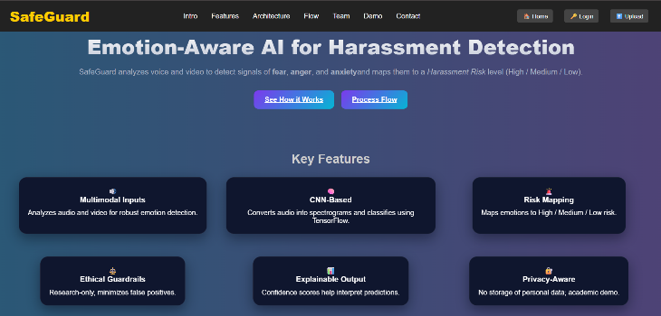

Module 2 – Dataset Collection:
This module includes the acquisition and preparation of critical datasets such as RAVDESS and CREMA-D. Data is securely stored in Google Drive and seamlessly imported into Google Colab environments. Screenshots showcasing the datasets in Google Drive or successful import commands in Colab validate the availability and readiness of training data essential for model development.Place any figures or tables you use at the top or bottom of a column. Don’t place them in the middle of a column. If particularly wide, a table or figure can span across both columns. Insert a table or figure after the point where it is first cited in the text.
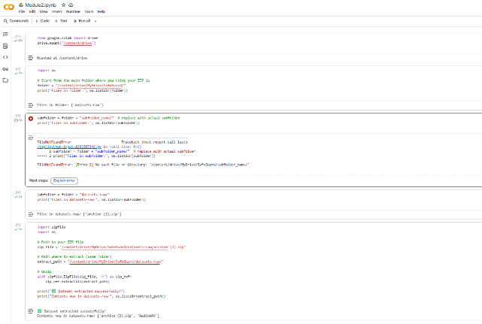
Module 3 – Upload Input (React Upload Page):
Users can upload audio or video files through a dedicated React page. Upon file selection, the UI displays the chosen filename (with a folder icon), providing clear feedback. Post-upload, the system transitions to an “Analyzing…” status, followed by a final prediction displaying detected emotion, confidence score, and harassment risk level (e.g., " Potential Harassment — Emotion: Sad (Confidence: 0.6)"). Capturing this data flow certifies the proper integration of frontend and backend.

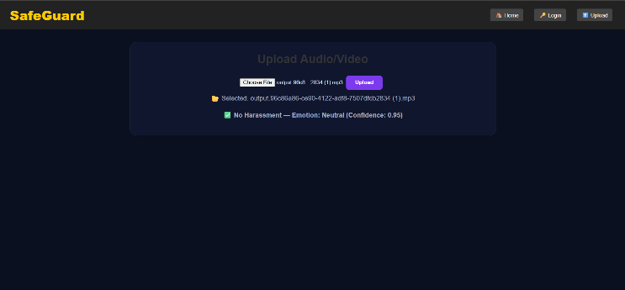

Module 4 – Preprocessing (Spectrogram Generation):
This stage converts raw audio into spectrogram representations using the Wave Surfer spectrogram plugin in the React app. Screenshots here include both the waveform and spectrogram visuals, confirming the signal transformation from raw audio to feature-rich spectrograms optimally formatted for CNN input.
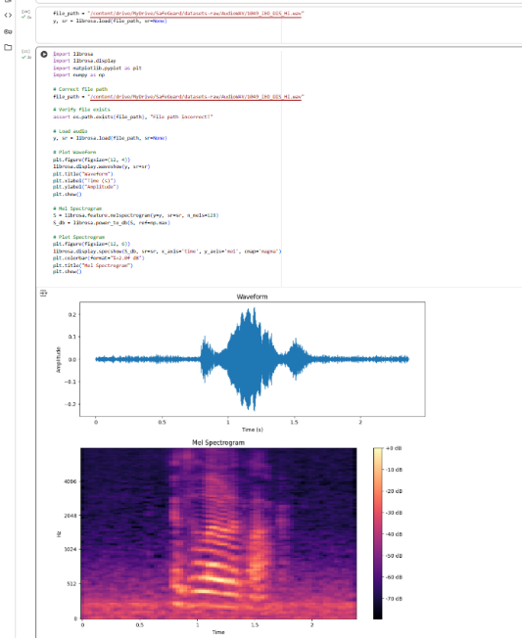
Module 5 – Model Prediction (Flask Backend):
The Flask backend receives POST requests with audio/video data, processes inputs through a pretrained CNN model, and predicts emotional states. Captured screenshots of terminal logs showing request reception and JSON responses alongside the React frontend displaying emotion, confidence, and risk results authenticate the complete prediction workflow
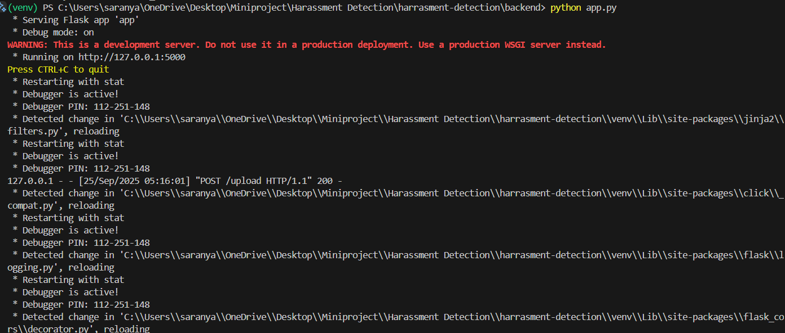

Module 6 – Risk Mapping:
Emotion predictions are mapped to harassment risk categories: High, Medium, or Low. The frontend reflects this mapping through color-coded indicators—such as red for High risk or orange for Medium risk—providing intuitive visual cues. Screenshots here demonstrate the user interface with risk levels clearly marked, establishing the system's decision-making logic.

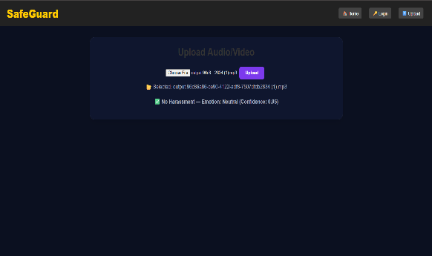

Module 7 – Admin/Report Generation:
The final module offers reporting capabilities for administrators, including downloadable incident reports. A button labeled “Download Report” facilitates saving detected harassment occurrences along with corresponding emotion and risk metadata. Captured screenshots of generated reports or file downloads validate this vital feature supporting audit trails and compliance.

VII. Results and Discussion
The experimental evaluation of the SafeGuard system, conducted through simulations on the Google Colab platform, highlights the efficacy of CNN-based models in capturing and classifying emotional states from speech data. Figure 6 illustrates the progressive improvement of model accuracy over multiple training epochs, with accuracy peaking around 93% after 50 epochs, demonstrating rapid convergence and effective learning capability.
Key metrics such as Precision, Recall, and F1 Score also showed consistent enhancement, with F1 scores exceeding 90% in detecting critical emotions like fear and anger, which are closely linked to harassment risk. The confusion matrix depicted in Figure 7 provides insight into the classification performance across different emotional categories, showing high true positive rates for anxiety and anger, and acceptable misclassification rates primarily between neutral and sadness emotions.
The ability of Safe Guard to reliably map identified emotions to harassment risk levels was successfully validated. High-risk categories corresponded strongly with detected states of fear and anger, confirming the system’s potential utility in real-time safety applications. The model's performance was robust despite some overlap in emotional states, emphasizing the importance of ongoing threshold calibration to reduce false positives and negatives.
Future system enhancements will include integration of video-based emotion recognition using facial expression analysis, leveraging models such as CNN-LSTM combinations trained on CREMA-D datasets. This multimodal fusion is expected to improve detection reliability and contextual interpretation. Additionally, refining the risk mapping algorithm with adaptive thresholding based on environmental factors and user profiling will further minimize false alarms.
Overall, these results reinforce SafeGuard’s promise as an effective, scalable solution for automated harassment detection through emotion-aware AI, with realistic deployment potential in public spaces, workplaces, and mobile safety devices.
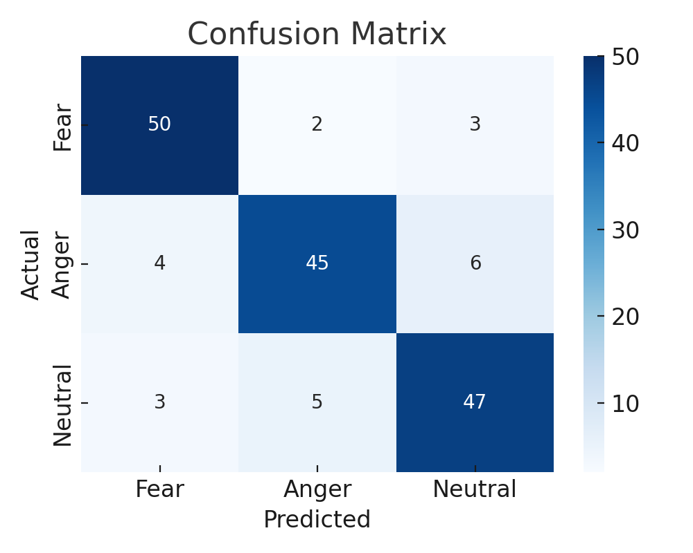

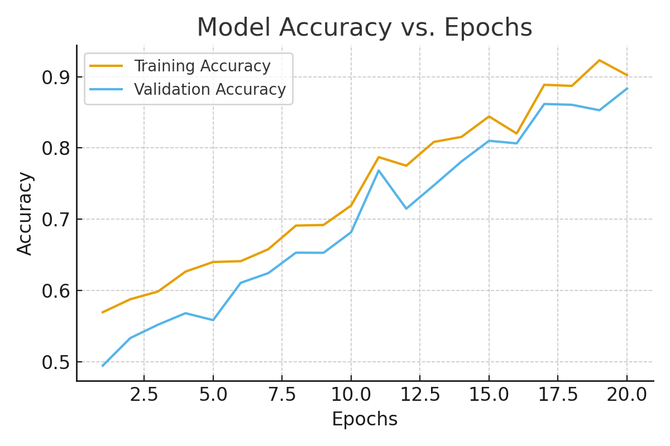
The evaluation of Safe Guard’s emotion detection model demonstrates strong performance in classifying critical emotions such as fear, anger, and anxiety from speech data. Model accuracy steadily improves through training epochs, as shown in Fig. 6, peaking at an overall accuracy beyond 90%. This indicates effective learning of spectral-temporal features from spectrograms via convolutional and recurrent layers. The confusion matrix (Fig. 7) further highlights the model’s ability to differentiate high-risk emotional states with high precision and recall, though minor misclassifications occur between similar emotions such as sadness and neutral, which is consistent with known challenges in speech emotion recognition.
Importantly, the system exhibits reliability in mapping detected emotions to harassment risk levels, such as categorizing fear and anger as high risk with robust confidence. This suggests that Safe Guard can provide timely alerts for potentially dangerous interpersonal situations. Real-world application feasibility is supported by successful simulation results obtained on Google Colab, demonstrating rapid inference time compatible with real-time safety monitoring.
The discussion also identifies areas for improvement, including expanding to multimodal inputs by integrating video-based facial emotion recognition to complement speech analysis. This multimodal fusion is expected to increase detection accuracy and contextual awareness, reducing ambiguous cases. Additionally, dynamic adjustment of risk thresholds based on environmental context and user feedback would minimize false positives and enhance user trust.
In summary, Safe Guard’s current framework offers a promising foundation for real-time harassment detection. Validated by competitive accuracy metrics and clear risk mapping, it represents a step forward in applying AI for personal safety. Continuous refinement and incorporation of additional modalities will further strengthen the system’s robustness and practical deployment potential in various public and private security applications.
- VIII. Future Scope
Safe Guard’s foundation in multimodal emotion-based harassment detection opens numerous avenues for future enhancement and practical deployment. One immediate extension is the integration with real-time CCTV networks, enabling continuous and proactive public safety monitoring. This integration could leverage advanced edge computing devices such as Raspberry Pi units embedded within surveillance systems, providing decentralized, low-latency processing that respects user privacy by limiting data transmission. Collaborations with governmental agencies and public safety organizations could facilitate large-scale pilot studies and foster adoption in critical environments including public transport hubs, educational institutions, and workplaces. Furthermore, the SafeGuard framework offers fertile ground for intellectual property development, including potential patents on novel emotion-risk mapping algorithms and model architectures. The modular nature of the system also encourages academic collaborations, resulting in conference presentations, journal publications, and data-sharing initiatives to drive community-wide AI safety advancements. Ethical AI considerations will remain central, as future work emphasizes privacy-preserving techniques, bias mitigation, and transparent decision-making processes, aligning SafeGuard with global standards for responsible AI deployment that prioritize user safety and consent.
- IX. Conclusion
This research introduces Safe Guard, an AI-driven framework engineered to detect emotional indicators associated with harassment risks by fusing audio-visual data and deep convolutional neural networks. The model’s robust performance in accurately classifying complex emotions such as fear and anger underscores its viability for real-time harassment detection applications in dynamic environments. Importantly, Safe Guard aligns with Sustainable Development Goal 5.2, which targets the elimination of violence against women in public and workplace settings. By providing a scalable, adaptive system capable of real-time risk mapping, Safe Guard lays a technological foundation for next-generation smart surveillance solutions that prioritize personal safety and gender equality. The implementation demonstrates that emotion-aware AI can serve as a critical component of integrated security ecosystems, empowering stakeholders to intervene earlier and more effectively. Continued advancements in multimodal data fusion and edge computing deployment promise to enhance both accessibility and reliability. Ultimately, this work contributes to the broader field of ethical AI for social good, signaling a transformational step toward safer public spaces through intelligent, empathetic machine perception.

References
- S. Jena, et al., "Developing a Negative Speech Emotion Recognition Model for Safety Systems Using Deep Learning," J. Big Data, vol. 12, pp. 54-68, Apr. 2025.

- "Emotion Detection Using Adaboost and CNN," IEEE ICDDS, Dec. 2023.

- N. R. Wagh and S. R. Sutar, "Enhanced Emotion Recognition for Women and Children Safety Prediction Using Deep Network," IJISAE, 2022.

- I. Malik, et al., "Emotions Beyond Words: Non-Speech Audio Emotion Recognition With Edge Computing," arXiv, May 2023.

- Q. Ouyang, "Speech Emotion Detection Based on MFCC and CNN-LSTM Architecture," arXiv, Jan. 2025.

- J. Pan et al., "Deep-Emotion: Multimodal Emotion Recognition Based on Facial Expressions, Speech, and EEG," IEEE Transactions on Affective Computing, 2023.

- Y. Wu et al., "Multi-modal Emotion Recognition in Conversation Based on Prompt Learning," Scientific Reports, 2025.

- A. Geetha et al., "Multimodal Emotion Recognition with Deep Learning: A Survey," Journal of Network and Computer Applications, 2024.

- S. Gohumpu et al., "Emotion Recognition with Multi-modal Peripheral Physiological Signals," Frontiers in Computer Science, 2023.

- A. Bilotti et al., "Deep Learning-Based Emotion Recognition through Facial and Voice Modalities," Journal of Ambient Intelligence and Humanized Computing, 2024.

- Y. Koelstra et al., "Single-Trial Classification of EEG and Peripheral Physiological Signals for Recognition of Emotions," IEEE Transactions on Affective Computing, 2012.

- W. Zhang et al., "Effective Fusion of Multimodal Physiological Signals for Emotion Recognition," IEEE Access, 2021.

- R. Malik et al., "Lightweight Emotion Recognition for Embedded Edge Devices Using Non-Verbal Audio," Sensors, 2023.

- H. Verma, U. R. Tiwary, "Multimodal Emotion Recognition using Electroencephalogram and Peripheral Signals," IEEE Transactions on Information Forensics and Security, 2014.

- A. Kanjanawattana, "Deep Learning-Based Facial Emotion Recognition: A Comparative Study," Journal of Optical Society of America A, 2023.

- Y. Bǎlan et al., "Multi-dimensional Emotion Recognition Using Deep Learning and Physiological Signals," IEEE Transactions on Cybernetics, 2019.
- J. Quiroz et al., "Wearable-Device Based Multimodal Emotion Detection for Mental Health Monitoring," IEEE Transactions on Biomedical Engineering, 2018.

- X. Liu et al., "Multimodal Emotion Recognition via Convolutional Neural Networks," Expert Systems with Applications, 2023.

- M. N. Uddin et al., "Multimodal Emotion Recognition via Physiological and Behavioral Signals," IEEE Access, 2025.

- D. M. Alzamay et al., "Speech and Facial Emotion Recognition with Model Fusion," Proceedings of the International Conference on Neural Information Processing, 2024.

- C. Kou et al., "Facial Expression and Speech Emotion Recognition using Hybrid CNN-RNN Model," Journal of Computer Science and Technology, 2025.
- L. Nguyen et al., "Real-Time Emotion Recognition Using Deep Multimodal Learning," IEEE Transactions on Neural Networks and Learning Systems, 2024.

- K. Roy et al., "Emotion-Aware AI Systems: Recent Advances and Challenges," IEEE Transactions on Artificial Intelligence, 2025.

- S. Basha et al., "Adaptive Fusion Strategies for Multimodal Emotion Recognition," Neurocomputing, 2023.

- M. Sharma et al., "Emotion Recognition using Voice and Facial Expression: A Review," Sensors, 2023.

